Assignment of the Problem: 21.10.2024
Date of Submission: 08.11.2024

Problem 8: Case Study of Graph Manipulation Algorithms: You are required to apply the following algorithms on the Network graph shown in Figure 1.
- Assume a as initial vertex to traverse the graph shown in Figure 1 then what will be final output when applied the following algorithms.
  - Breadth First Search
  - Depth First Search
- Find the minimum spanning tree using the following algorithms.
  - Prim’s Algorithm
  - Kruskal’s Algorithm

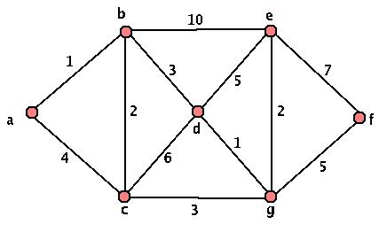
Figure 1. Network Graph

